PROJECT FALCON
Design and Development of a Solar-Powered Smart Coastal Observation Buoy with Event-Driven Cloud Telemetry for Pressure-Derived Wave Monitoring and AI-Assisted Short-Term Prediction
A Capstone Proposal — Chapters 1 and 2
Project FALCON Research Group
Bachelor of Science in Information Technology, Fullbright College
October 2026 — proposal stage; hardware integration and field validation pending

CHAPTER 1 — INTRODUCTION

1.1 Background of the Study
Coastal waters support transportation, fisheries, tourism, environmental protection, and disaster preparedness, and millions of Filipinos depend on daily decisions about sea conditions. Reliable, site-specific marine observations therefore have clear public value. Commercial observation buoys exist and perform well, but their acquisition, maintenance, and operating costs place them beyond the reach of most local government units, schools, and coastal organizations. At the same time, recent advances in microcontrollers, long-range low-power telemetry, solar energy systems, and machine learning have made it feasible for a student research team to design, build, and evaluate an affordable coastal observation platform. Project FALCON (Fullbright College’s AI-powered Live Coastal Observation Network) is proposed as such a platform: a solar-powered smart coastal observation buoy paired with event-driven cloud telemetry, intended to estimate wave conditions from underwater-pressure variation, observe local wind, and research short-term wave prediction as an undergraduate development study. This chapter presents the background of the study in international, national, and local contexts, reviews related literature and studies, states the conceptual framework, significance, problem, scope, and key terms.

1.1.1 International Context
Globally, sustained ocean observation underpins maritime safety, weather analysis, and climate assessment, yet dense near-shore coverage remains uneven because professional instruments are costly to buy and maintain. Commercial wave buoys such as the Datawell Directional Waverider and NexSens modular platforms provide accurate wave and environmental measurements and serve as professional benchmarks, but they are intended for government agencies and large research institutions (see Section 1.3). This cost barrier has motivated a worldwide stream of low-cost buoy research within the last seven years. Zhang et al. (2020) presented an integrated solar-powered buoy system, showing the importance of deliberate sensor integration and power design. More recently, Williams et al. (2025) reported a compact autonomous platform for current and seawater-parameter observation, reinforcing that modular, reproducible student-scale buoys are feasible.
On measurement science, the recent international literature shapes this study in two ways. First, buoys do not observe the sea surface directly; they infer it through platform motion and sensor response, so hull response, mooring, transfer functions, and noise affect every result (Ardhuin et al., 2019; Zhou et al., 2022). Second, subsurface pressure can be converted to surface elevation only with documented treatment of sensor depth, frequency-dependent attenuation, and nonlinearity; recent laboratory work by Martins et al. (2022) confirms that reconstruction quality depends on water depth, frequency, and the transfer formulation. Foundational pressure theory older than the 5- to 7-year window is acknowledged as background but is not counted among the recent sources. The recent literature therefore supports the direction of this study while imposing its central discipline: an affordable buoy may estimate wave statistics, but only calibration against an independent reference turns readings into defensible measurements.

1.1.2 National Context
The Philippines is an archipelagic nation of more than 7,600 islands whose coastal waters carry fishing, inter-island transport, tourism, and disaster-response activity. The Philippine Atmospheric, Geophysical and Astronomical Services Administration (PAGASA) is mandated to improve weather and sea-condition analysis, wave forecasting, and marine warnings, while the National Mapping and Resource Information Authority (NAMRIA) maintains tide stations and provides tidal and oceanographic information (PAGASA, n.d.; NAMRIA, 2025). These national functions establish the public importance of marine observation.
National capability does not, however, reach every shoreline. Many local government units, public schools, and coastal organizations have no site-specific instrument of their own and cannot fund commercial buoys. A locally built, low-cost, maintainable observation buoy therefore addresses a recognizable national need: affordable instruments that barangays, campuses, and small research groups can deploy, understand, and repair. Consistent with this role, Project FALCON is framed strictly as a research and local decision-support prototype; it does not replace PAGASA forecasts, coast guard instructions, navigation equipment, or official emergency-warning systems.

1.1.3 Local Context
This study is undertaken as an undergraduate capstone project of the Bachelor of Science in Information Technology program of Fullbright College by the Project FALCON Research Group. The intended pilot setting is a near-shore barangay coastline where a moored buoy reports to an approved cloud/edge endpoint, and where the intended dashboard readers include older or non-technical operators such as fisherfolk leaders and barangay staff. That audience shapes concrete design choices carried through the whole study: four dashboard pages (Overview, Buoy Motion, Sensors, Logs & Alerts), large text, plain labels, and explicit source and freshness states on every value.
The local context also fixes the deployment boundaries used in Chapter 2. The buoy carries an ESP32 controller, water pressure sensor, wind speed/direction sensor, GPS module for position and security, battery/solar power system, Wi-Fi/LTE internet telemetry, and required protection electronics, with no mini-PC on the water. A 4G/LTE modem may be installed on the buoy for remote field trials, while storage, processing, prediction, dashboard hosting, and alerts run on the approved cloud/edge service. The ESP32 continues local sampling and buffering during Internet interruption, then uploads records when the link returns.

1.2 Review of Related Literature
This section synthesizes related literature thematically. Full discussion and the complete reference list appear in the References section at the end of this document.

1.2.1 Low-Cost and Autonomous Marine Monitoring Platforms
3. Low-Cost and Autonomous Marine Monitoring Platforms
Albaladejo et al. (2012) demonstrated that a compact wireless sensor buoy can support shallow-marine monitoring when affordability, stability, data acquisition, communication, and autonomous power are treated as parts of one system. Zhang et al. (2020) later presented an integrated solar-powered monitoring buoy, illustrating the importance of deliberate sensor integration and power design. More recently, Williams et al. (2025) reported a compact autonomous platform for current and seawater-parameter observations, reinforcing the feasibility of modular and reproducible buoy systems.
These studies support FALCON's hardware-first and modular approach, but their existence means that low cost and sensor integration alone are not sufficient novelty. FALCON must demonstrate measurable value from its particular combination of calibrated wave observation, edge processing, transparent short-horizon prediction, local buffering, energy monitoring, and security logic. Its contribution should therefore be evaluated as an integrated local implementation rather than presented as the invention of an autonomous buoy.
The reviewed platforms also show that physical design cannot be separated from information-system design. Hull geometry, ballast, freeboard, mooring, antenna placement, cable entry, enclosure temperature, and solar exposure influence the quality and continuity of the data that eventually appear on the dashboard. For this reason, the final study must document both the electronic architecture and the buoy's physical configuration.

1.2.2 Motion-Based and Pressure-Assisted Wave Measurement
4. Motion-Based and Pressure-Assisted Wave Measurement
Zhou et al. (2022) described a miniaturized strapdown inertial wave sensor that uses orientation, acceleration, coordinate transformation, integration, and signal analysis to obtain wave information. Ardhuin et al. (2019), however, emphasized that wave buoys infer the sea surface through buoy motion. Hull response, mooring, transfer functions, phase response, and sensor noise therefore affect the resulting spectrum. Thomson et al. (2018) similarly demonstrated the capability of inexpensive open-source wave buoys while underscoring the importance of validation and processing.
For FALCON, these findings justify investigating a inertial measurement unit (excluded from the Phase 1 scope; retained as background only), but they do not validate the inertial measurement unit itself as an oceanographic wave instrument. Raw vertical acceleration must not be labeled directly as wave height. The method must account for sensor orientation, gravity removal, bias, filtering, integration drift, sampling rate, time synchronization, buoy response, and mooring effects. The actual float dimensions, mass distribution, waterline, ballast, stabilizers, IMU location, and enclosure orientation must be recorded because these variables affect the relationship between water motion and measured buoy motion.
Pressure sensing can provide an independent or complementary observation, but pressure is also not automatically equivalent to surface elevation. Bishop and Donelan (1987) showed that subsurface pressure records require compensation and careful handling of high-frequency data. Bonneton et al. (2018) and later laboratory work by Martins et al. (2022) showed that reconstruction quality depends on water depth, frequency, nonlinearity, and the transfer formulation. Pressure attenuation increases with sensor depth, and inappropriate reconstruction can understate or distort wave components.
Consequently, FALCON should describe its Phase 1 output as a calibrated estimate of wave statistics rather than an instrument-grade measurement until comparison testing is completed. A pressure-assisted method should only be claimed if the water-pressure sensor has sufficient resolution, sampling performance, waterproof installation, and a documented conversion method. Controlled tank tests and near-shore comparison against a staff gauge, synchronized video, reference pressure logger, acoustic gauge, or validated wave instrument are necessary.

1.2.3 Solar Energy, Edge Computing, and Data Quality
5. Solar Energy, Edge Computing, and Data Quality
Marine autonomy depends on the balance among sensing, computation, communication, energy harvesting, and storage. Cho et al. (2021) treated battery behavior, communication, and load optimization as an integrated system and showed the value of degradation awareness and multiple power-saving strategies. Grare et al. (2021) demonstrated the integration of GPS, IMU, wind, pressure, and other instruments on autonomous wave platforms and described power cycling of higher-consumption components.
These findings support FALCON's division of work. The ESP32 can perform deterministic acquisition, timestamping, buffering, and essential health or displacement checks, while the Orange Pi can perform signal processing, database services, dashboard delivery, and eventual model inference. This division can preserve basic sensing if the higher-level computer restarts or enters a low-power mode. Nevertheless, the architecture must be validated through a measured load table and daily energy budget rather than component ratings alone.
Skålvik et al. (2023) identified calibration drift, corrosion, limited energy, unreliable links, and the absence of external references as persistent causes of poor ocean-sensor data. Their work supports local quality control before transmission. Each FALCON record should therefore carry time validity and sensor-health information. Range checks, missing-data detection, stuck-value detection, pressure and motion plausibility, GPS quality, battery state, leak status, and cross-sensor consistency should be implemented and reported. Prediction must be suppressed or visibly marked unreliable when the required inputs fail these checks.

1.2.4 Coastal Communications and Position Monitoring
6. Coastal Communications and Position Monitoring
Marine telemetry must tolerate intermittent connectivity. A practical system needs local storage, sequence numbers, retry logic, duplicate handling, and delayed synchronization rather than assuming an uninterrupted link. The open Wi-Fi/LTE buoy reported by Dreyer et al. (2026) is useful emerging evidence for low-power coastal telemetry, but it remains a preprint and should not be the sole basis for selecting a communication technology. FALCON's final choice among Wi-Fi, Wi-Fi/LTE, cellular, or a hybrid arrangement should be justified through measured range, packet-delivery rate, latency, energy use, coverage, and operating cost at the proposed site.
Position monitoring is relevant both to platform health and security. GPS movement can result from normal receiver error, anchor swing, tide, currents, waves, anchor drag, authorized maintenance, or theft. A position threshold alone will therefore produce false alarms. Raja Ali et al. (2026) used an ESP32, GNSS, GSM telemetry, solar power, and local storage for buoy position monitoring and reported substantial differences between the monitored location and reference GNSS during field testing. Although this is recent evidence and should be treated cautiously until its publication status and full methods are reviewed, it illustrates why geofencing must include uncertainty and environmental motion.
FALCON should combine a sustained geofence breach with abnormal displacement rate, unusual tilt or handling motion, loss of expected mooring behavior, and time persistence. Alerts should be classified as advisory, warning, or probable tampering rather than asserting theft as a fact. Tests must include normal anchor swing, GPS noise, strong wave motion, authorized retrieval, simulated anchor drag, and unauthorized displacement. Performance should be reported using detection rate, false-alarm rate, detection delay, and location error.

1.2.5 Short-Horizon Wave Prediction and Explainability
7. Short-Horizon Wave Prediction and Explainability
Fan et al. (2020) demonstrated the ability of long short-term memory networks to learn temporal dependencies in significant wave-height records. Song et al. (2023) combined ensemble empirical mode decomposition and deep learning to address nonlinear and non-stationary wave series. Mo et al. (2024) organized the broader field into feature selection, base prediction, decomposition, and optimization. Liu et al. (2024) further showed that environmental variables can be combined to predict buoy attitude using a complex multidimensional model.
These studies establish the feasibility of data-driven prediction, but they do not prove that FALCON can accurately forecast ten minutes ahead. Most were trained on established datasets, larger platforms, numerical-model output, longer time horizons, or many synchronized features. A newly assembled low-cost buoy will initially have limited and potentially noisy local data. Therefore, the dashboard's current predicted trace must be identified as simulated or demonstration output until a trained model has passed held-out field evaluation.
The study must define one primary target before model development. The recommended target is ten-minute-ahead significant wave height or a clearly defined sea-condition class computed over a stated observation window. Instantaneous wave height should not be confused with significant wave height. The ten-minute horizon is a proposed operational requirement and must be justified by stakeholder needs and empirical performance; it is not yet an established capability.
Model evaluation should begin with simple baselines: persistence, moving average, linear regression, and a small tree-based model. A compact GRU or LSTM should only be retained if it consistently improves performance on unseen chronological periods while meeting Orange Pi memory, latency, and power constraints. Random splitting must be avoided because adjacent wave samples can leak future information into training. Report MAE, RMSE, R² where appropriate, error by sea state, inference latency, model size, missing-data behavior, and energy impact. If classification is chosen, add precision, recall, and F1-score.
Explainability should be modest and verifiable. The interface may show the input window, data-quality status, recent baseline error, model version, prediction horizon, and uncertainty interval. Feature influence may be reported only if computed by a documented method. A fixed percentage labeled as “confidence” is not valid unless it is calibrated against observed forecast errors. The uncertainty band should be derived from residuals, probabilistic output, ensembles, conformal prediction, or another stated procedure.

1.2.6 Philippine and Palawan Context
8. Philippine and Palawan Context
PAGASA provides sea-condition analysis, wave forecasts, and marine warnings for Philippine waters, while NAMRIA maintains tide stations and distributes oceanographic and bathymetric information. These services demonstrate that marine measurements are nationally important and also provide possible reference data for site characterization and comparison. They should not be described as direct competitors to a student prototype; their scale, mandate, instrumentation, and quality-control responsibilities are different.
The local need for FALCON must still be demonstrated rather than assumed. Before final approval, the researchers should identify a specific Palawan test community or partner and document its current decision process, information gaps, connectivity, maintenance capacity, and acceptable deployment area. Interviews or letters of support from a local government unit, coastal disaster office, fisherfolk organization, port, school, or environmental office would provide stronger evidence than a broad statement that coastal communities need data.
Site selection must also consider permits, navigational safety, protected-area rules, mooring authorization, retrieval access, storm exposure, cellular or radio coverage, and the availability of a reference observation. Field deployment should begin in a controlled, accessible near-shore location and must not be presented as a replacement for PAGASA warnings or certified navigational instruments.

1.3 Review of Related Studies
Existing systems fall into two groups, and neither closes the gap this study addresses. Commercial wave buoys (Datawell Directional Waverider, NexSens platforms) measure accurately but are expensive, proprietary, and aimed at professional institutions. Typical low-cost academic prototypes (ESP32/Arduino/Raspberry Pi builds, including IoT water-quality networks) demonstrate real-time acquisition and display but stop at data collection and visualization, rarely adding calibrated wave estimation, autonomous power validation, or prediction evaluated against baselines.
Table 1. Comparison of existing systems and Project FALCON.
Feature | Commercial Wave Buoys | Typical Low-Cost Prototypes | Project FALCON (Proposed)
Real-time monitoring | Yes | Yes | Yes (proposed)
Solar-powered autonomy | Yes | Some | Yes, to be measured
Open-source hardware | No | Yes | Yes
Low cost / locally maintainable | No | Yes | Yes (design goal)
Calibrated wave estimation | Yes | Rare | Proposed; pending validation
AI-assisted wave analysis | Rare | Rare | Proposed; vs. baselines
Local web dashboard | Limited | Some | Four pages (proposed)
Designed for PH coastal deployment | No | Limited | Yes (design goal)
The comparison yields the research gap: no reviewed affordable platform combines, in one documented and locally maintainable build, a stable floating platform, autonomous solar-powered operation, timestamped Wi-Fi/LTE cloud telemetry with outage recovery, cloud/edge processing and storage, calibrated pressure-derived wave estimation, transparent short-term prediction tested against non-AI baselines, and a dashboard usable by non-technical operators. Studies that attempt many parameters at once further pay for breadth with complexity, cost, calibration load, and maintenance effort; FALCON deliberately narrows Phase 1 to pressure-derived wave sensing plus wind speed and direction as the primary measurements, with GPS, power, timestamps, and security states as supporting telemetry, and water temperature and other environmental sensors excluded.
Project FALCON addresses the gap as an integration-and-evaluation study rather than an invention claim. It does not propose a new sensor or a new AI algorithm; it proposes to combine established components into one reproducible near-shore research platform and to test, honestly and traceably, whether that platform measures, communicates, powers itself, alerts sensibly, reads clearly, and predicts better than persistence.

1.3.1 Synthesis and Research Gap
The reviewed literature converges on several conclusions. Affordable marine sensing is feasible, but successful platforms integrate physical design, sensors, power, communication, and maintenance. Inertial and pressure measurements can support wave estimation, but both require signal processing, calibration, and reference comparison. Solar autonomy requires measured energy balance and power-aware operation. Remote platforms require onboard data-quality checks and offline buffering. Machine-learning models can forecast wave variables, but performance on large historical datasets cannot be transferred automatically to a small locally built buoy.
The principal gap addressed by FALCON is therefore not the absence of smart buoys or wave-prediction algorithms. It is the lack, within the reviewed literature, of a reproducible student-scale system evaluated as a whole under a defined Palawan coastal use case. The proposed contribution combines:
• a low-cost ESP32 buoy with event-driven cloud telemetry architecture with fault-tolerant local acquisition;
• buoy-aware, calibrated motion-based wave estimation with pressure used only when technically validated;
• a clearly defined short-horizon prediction target evaluated against simple baselines;
• honest display of input quality, uncertainty, model version, and recent error;
• measured solar-energy balance and power-aware operating modes;
• multi-condition displacement and tamper alerts designed to limit false alarms; and
• local field evaluation, documented limitations, and reproducible hardware and software records.
Defensible novelty statement. Project FALCON is a locally developed, affordable, solar-powered coastal-monitoring prototype that integrates calibrated wave observation, edge data processing, an experimentally evaluated short-horizon wave prediction feature, and GPS/IMU-based displacement and system-health monitoring using a reproducible ESP32 buoy with event-driven cloud telemetry architecture. Novelty is claimed in the validated integration and local adaptation, not in any individual sensor or algorithm.
Prior work establishes the feasibility of low-cost marine platforms, inertial and pressure-assisted wave observation, energy-aware autonomy, onboard quality control, telemetry, and data-driven wave prediction. It also demonstrates why feature integration alone is insufficient. The scientific value of FALCON will depend on calibration, reference comparison, explicit uncertainty, measured energy and communication performance, controlled security testing, and a documented Palawan use case. With this scope, the project can make a credible BSIT contribution through the validated integration of embedded sensing, edge computing, data engineering, machine learning, and a human-readable monitoring interface.

1.4 Theoretical and Conceptual Framework
The study is guided by an Input–Process–Output (IPO) framework. The input layer consists of direct water pressure observations, wind speed/direction observations, GPS position/security telemetry, battery and solar power telemetry, and health/status telemetry. The process layer consists of ESP32 acquisition (timestamping, validation, framing, buffering), the Wi-Fi/LTE cloud transport link to the approved cloud endpoint, and the cloud/edge service services (authentication, deduplication, storage, processing, prediction, alerts, API). The output layer consists of retained records, derived wave statistics, predictions, and operator messages, closed by evaluation evidence that determines whether each output is accurate, reliable, usable, and safe within the stated scope.
[FIGURE PLACEHOLDER] Figure 1. Input–Process–Output conceptual framework (to be inserted; same framework as Chapter 2, Figure 1).
The framework enforces one theoretical rule across all chapters: no stage may impersonate another. What is measured (pressure, wind) is reported as MEASURED; what is derived (wave height) is reported as ESTIMATED; what the model produces is PREDICTED; what the simulator produces is SIMULATED; and anything uncalibrated is flagged CALIBRATION REQUIRED. This separation is the study’s answer to the established caution that every observing platform and processing method carries its own response and uncertainty (Ardhuin et al., 2019).

1.5 Significance of the Study
Coastal residents and fisherfolk. A readable, site-specific display of current wave estimates, wind observations, and system freshness helps daily go/no-go judgments at the shoreline. The study contributes decision support only; safety authority remains with PAGASA, the coast guard, and official warnings.
Barangay and municipal (LGU) offices. An affordable, locally maintainable platform with an approved cloud endpoint gives local offices their own near-shore record — useful for incident awareness, planning, and justifying further investment — without dependence on continuous Internet.
Students and Fullbright College. The project demonstrates a complete capstone arc: requirements, architecture, prototype, controlled testing, evaluation, and revision, integrating embedded systems, telemetry, databases, web presentation, renewable energy, and applied machine learning in one artifact the school can exhibit and extend.
Researchers and future developers. Versioned firmware, schema, calibration coefficients, chronological evaluation protocol, and published limitations give the next team a traceable baseline instead of a black box, including explicit negative results if any subsystem fails its acceptance test.

1.6 Statement of the Problem
General problem. This study designs and develops Project FALCON, a solar-powered smart coastal observation buoy with event-driven cloud telemetry, capable of pressure-derived wave monitoring and AI-assisted short-term wave height prediction using a focused set of IoT sensors, and evaluates whether the integrated platform meets defined acceptance criteria for measurement, communication, power, alerting, usability, and prediction.
Specifically, this study seeks to answer the following questions:
1. How accurately and repeatably can calibrated underwater-pressure variation estimate the selected wave-height statistic during controlled trials?
2. How reliably can the ESP32–Wi-Fi/LTE–cloud/edge service path deliver timestamped records and recover from link or Internet outages without silent data loss or duplication?
3. Can the solar-battery subsystem sustain the required buoy operating schedule under measured load and reduced-sun conditions?
4. How effectively can persistent geofence and enclosure/tamper rules identify abnormal events without treating ordinary motion or GPS scatter as theft?
5. Can older or non-technical operators understand the four-page dashboard and complete essential monitoring tasks with minimal assistance?
6. Does the selected AI method improve on non-AI baselines for one defined short-term wave-height target on chronologically held-out calibrated data?
These six questions map one-to-one onto the methodological instruments of Chapter 2, Table 1 (sensor-reference comparison; Wi-Fi/LTE cloud upload scenarios; instrumented power logging; controlled false-alert scenarios; task-based usability testing; chronological hold-out against persistence baselines).

1.7 Scope and Delimitations; Definition of Terms
Scope and Delimitations
The study covers the design, prototype implementation, controlled testing, and evaluation of one solar-powered buoy node and one cloud/edge service for near-shore research use. Primary Phase 1 measurements are pressure-derived wave sensing and wind speed/direction; GPS, power, timestamps, and security states are supporting telemetry. The deployment pressure candidate is the Holykell HPT604 Type A (provisional 0–2 mH2O vented gauge, 4–20 mA), pending written supplier confirmation of continuous-saltwater suitability and calibration; a bench-only Bar02 sensor is used solely for supervised bench comparison. Final Wi-Fi access point or LTE modem, antenna, SIM/data plan, endpoint, authentication, protocol, and cloud/edge host are selection gates documented in the selection register. The study excludes continuous open-sea deployment, official forecasting or warnings, water-temperature/salinity/chemistry sensing, and any claim of accuracy before reference validation. All energy figures prior to instrumented logging are calculations, not measurements; all simulator outputs are workflow demonstrations, not field evidence.
Definition of Operational Terms
MEASURED. A value read directly from a calibrated sensor channel (e.g., underwater pressure, wind speed).
ESTIMATED. A value derived from measured quantities through documented processing (e.g., significant wave height from pressure); labeled ESTIMATED and CALIBRATION REQUIRED until reference validation is complete.
PREDICTED. The output of the AI short-term model for a frozen target (recommended: 10-minute-ahead estimated Hs); withheld when inputs are invalid, stale, or uncalibrated.
SIMULATED. Software-generated values used to demonstrate workflow; never field evidence.
Significant wave height (Hs). The defined primary wave statistic: the mean of the highest third of waves over a stated window, estimated from pressure in this study.
Cloud/edge service. The approved service endpoint that authenticates, stores, processes, predicts, alerts, and serves the dashboard for authorized users.
Wi-Fi/LTE cloud link. The low-rate buoy-to-cloud telemetry path; site range and reliability are selection gates requiring testing.
Persistence baseline. The non-AI reference forecast that future conditions equal current conditions; any AI candidate must beat it on untouched chronological test data to claim value.

CHAPTER 2 — METHODOLOGY

2.1 Research Design / Project Development Methodology
This study employs a developmental research design (design-and-development research) suited to information technology and computer science projects that produce an artifact rather than only test a hypothesis. The research proceeds through iterative cycles of requirements analysis, architectural design, prototype implementation, controlled testing, evaluation, and revision, because a low-cost marine monitoring platform can only be judged when its buoy, sensing, communication, and energy subsystems are engineered and evaluated as one integrated unit (Williams et al., 2025; Rojas et al., 2025).
The research follows an established design-and-development and mixed-methods orientation (Creswell & Creswell, 2023; Richey & Klein, 2007), combining iterative artifact development with quantitative measurement and qualitative usability feedback.
The study is applied experimental development: the artifact — a solar-powered coastal observation buoy paired with event-driven cloud telemetry — is built and then subjected to controlled trials that yield quantitative evidence of measurement quality, communication reliability, power autonomy, security behavior, usability, and short-term prediction accuracy. Consistent with the caution that every observing platform and processing method carries its own response and uncertainty (Ardhuin et al., 2019), the design separates what is measured, estimated, predicted, simulated, stale, and unavailable, so that no stage of the pipeline is allowed to impersonate another.
Both quantitative and qualitative strands are used. Quantitative measurements supply sensor error, communication performance, energy consumption, alert performance, usability task metrics, and prediction error. Qualitative comments gathered from authorized evaluators (advisers, faculty, and identified coastal-community users) capture clarity, comprehension, and maintenance difficulties that numeric indicators alone would not reveal. Development follows an iterative–incremental (agile-inspired) process in which each increment is frozen against a defined objective, tested, and only then carried forward. Table 1 maps the research objectives to their methodological instruments.
Table 1. Alignment of Research Objectives with Methodological Instruments
Specific objective (from Chapter 1) | Methodological instrument (Chapter 2)
Accuracy of pressure-derived wave estimate | Sensor-reference comparison; MAE, RMSE, bias (2.6)
Telemetry reliability and outage recovery | Wi-Fi/LTE cloud upload scenarios; packet-delivery metrics (2.6)
Solar-battery autonomy | Instrumented power logging; Wh/day energy budget (2.5–2.6)
Geofence/tamper alert behavior | Controlled false-alert scenarios (2.6)
Dashboard comprehensibility | Task-based usability testing with non-technical participants (2.6)
AI short-term prediction | Chronological hold-out vs. persistence baselines (2.6)

2.2 System Architecture / Framework
The approved architecture follows an Input–Process–Output (IPO) framework (see Figure 1). Water pressure observations, wind speed/direction observations, GPS position/security telemetry, battery and solar power telemetry, and health/status telemetry form the input layer; the ESP32 acquisition layer, the Wi-Fi/LTE cloud transport link, and the cloud/edge service services form the process layer; retained records, derived wave statistics, predictions, and operator messages form the output layer, closed by evaluation evidence that determines whether each output is accurate, reliable, usable, and safe for the stated research scope.
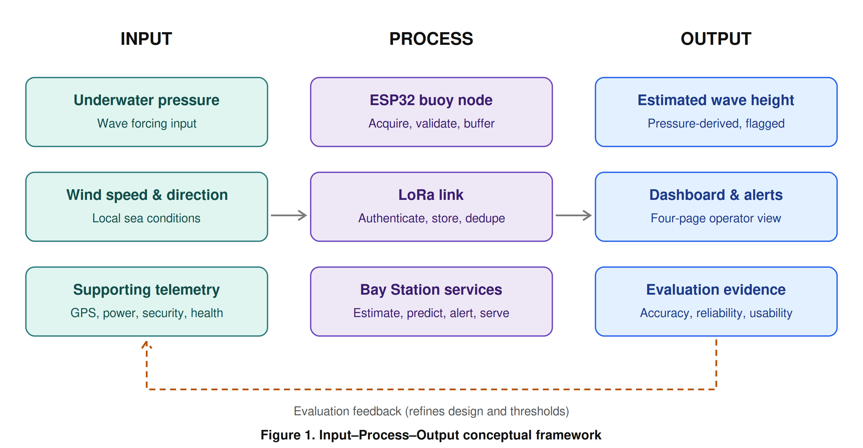
Figure 1. Input–Process–Output conceptual framework
The system is organized into five cooperating layers, each with an explicit responsibility and a defined failure behavior (Table 2). The buoy data is routed through a site-tested Wi-Fi/LTE cloud link to an approved cloud endpoint, and SIM/4G/5G is used only as the cloud/edge service cloud connectivity — never as the buoy direct connection. This separation lets local ingestion, storage, prediction, and dashboard services continue during Internet interruption (see Figure 2), a resilience property emphasized in recent integrated marine-IoT work (Cho et al., 2021; Rojas et al., 2025).
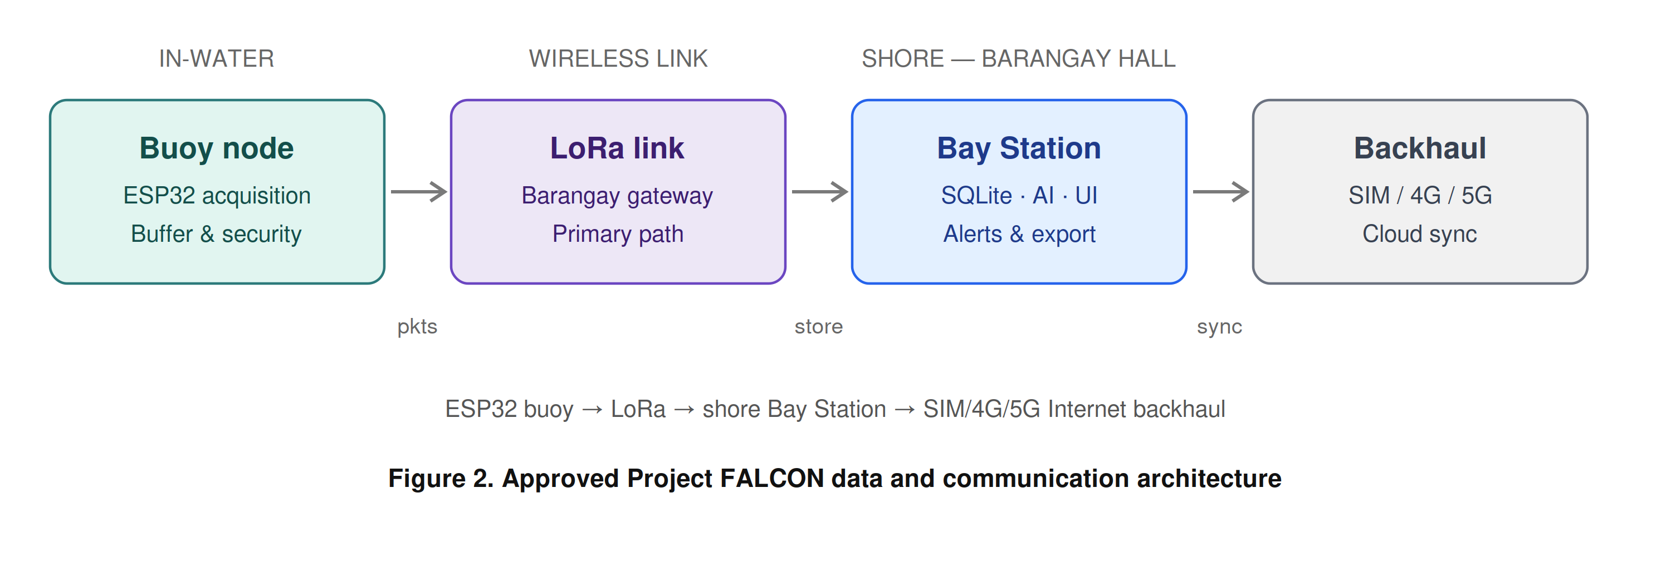
Figure 2. Approved Project FALCON data and communication architecture
Table 2. Approved Project FALCON Data and Communication Architecture
Layer | Responsibility | Failure behavior
Sensors and interfaces | Produce primary pressure/wind signals and supporting telemetry | Report invalid/unavailable states; do not substitute zero
ESP32 buoy node | Acquire, timestamp, validate, frame, secure, transmit, buffer | Continues sensing and local security during Wi-Fi/LTE loss
Wi-Fi/LTE cloud link | Carry compact packets to the approved cloud endpoint | Triggers buffering and timestamp-preserving retransmission
cloud/edge service | Authenticate, deduplicate, store, process, predict, alert, serve | Continues local operation during Internet loss
cloud connectivity | Cloud synchronization and authorized remote access only | Queues upload while local services remain available

2.3 Data Collection Methods
Data collection combines primary field data from the deployed prototype with secondary documentary data from datasheets, standards, and official meteorological references.
Primary data. The buoy acquires the core proposal data: underwater pressure for pressure-based wave behavior, wind speed and direction for local wind condition, GPS position for exact location and security/drift monitoring, and battery/solar telemetry for power validation. Underwater pressure is sampled at a rate justified by the target wave band, since pressure-based wave measurement is valid only when attenuation, sensor depth, and frequency response are handled correctly (Meulé et al., 2024; Zhou et al., 2025). Wind speed and direction are acquired through the prototype anemometer/vane assembly, and supporting telemetry — GPS position/time, battery/solar status, enclosure/security state, and system health — is acquired at independent, documented rates. Every record is assigned a station identifier, packet/sequence number, original sample timestamp, firmware/schema version, source label, and quality flags before transmission.
Secondary data. Documentary sources include the pressure-sensor datasheet and immersion guidance (Holykell, n.d.; Blue Robotics, n.d.) and official weather terminology used to frame safety boundaries without implying official forecasting (PAGASA, n.d.).
Reference and calibration instruments. Accurate evaluation requires an independent, time-aligned reference rather than the readings of the system itself. Before controlled trials, the pressure and wind channels are calibrated and the resulting coefficients versioned and recorded. Documentation follows the principle that sensor drift, corrosion, power limits, intermittent communication, and limited references are recurring threats to ocean-sensor data quality; the protocol therefore records metadata, quality flags, and maintenance history alongside raw values (Skålvik et al., 2023). For this study the independent references are (a) a measured water-column depth series using a rigid scale and a reference pressure source for the pressure channel, and (b) a reference anemometer and compass for the wind channel. Where a certified reference is unavailable, the water-column method and its stated uncertainty are reported instead, and no accuracy claim is made.
Data management. A single unified record schema is enforced end-to-end. Out-of-range, stale, disconnected, implausible, and stuck values are flagged or rejected, never silently replaced with zero. During Wi-Fi/LTE outages the node buffers a defined duration of records and preserves original timestamps on retransmission; the cloud/edge service authenticates buoy identity, prevents duplicate insertion, and logs rejected or malformed packets. Data are retained with backups, export capability, and a documented retention rule (Section 2.7).

2.4 Software and Tools Used
The prototype integrates embedded firmware, a cloud/edge service, a relational database, a web dashboard, and a machine-learning pipeline. Table 3 maps each functional area to the software and tools applied and to its purpose. Following the integrated-evaluation principle of prior marine buoy systems, marine sensing, communication, and battery behavior are treated as one evaluation unit (Cho et al., 2021; Wiranata & Widodo, 2026).
Table 3. Software and Tools Used in Development
Functional area | Software / tool | Purpose
Buoy firmware | ESP32 environment (PlatformIO/Arduino) | Acquisition, timestamping, framing, buffering, event-driven Wi-Fi/LTE upload
Shore service | Python (cloud/edge service) | Ingestion, validation, deduplication, processing, prediction, API
Database | SQLite | Local storage of original and derived records with version metadata
Dashboard | Responsive web front end (four pages) | Overview, Buoy Motion, Sensors, Logs & Alerts for non-technical operators
API services | REST/grouped endpoint layer | Serve dashboard and export requests; least-privilege access
Prediction | Python machine-learning libraries | Persistence/moving-average baselines and linear, tree-based, GRU, or LSTM candidates
Version control | Git repository | Firmware, schema, algorithm, and model versioning
Mechanical design | CAD software | Buoy geometry, stability, enclosure documentation (reference only pending redesign)
The dashboard navigation is fixed at four pages — Overview, Buoy Motion, Sensors, and Logs & Alerts — with GPS grouped under Supporting Telemetry and Settings kept as a compact header control. Large text, plain labels, and explicit source/freshness states serve older or non-technical operators (Mohammadi et al., 2024). The existing dashboard prototype is shown in Figure 4; any values displayed in simulator mode are not field measurements.

2.5 Development Procedures
Development proceeds through six approval-gated milestones (Table 4), each with a deliverable and an exit-evidence requirement so that no later stage builds on an unverified earlier stage.
Table 4. Development Milestones and Exit Evidence
Milestone | Deliverable | Exit evidence
M1 Scope freeze | Signed architecture, site/use case, wave statistic, AI target | Adviser approval record
M2 Component freeze | Exact BOM, datasheets, pinout, Wi-Fi/LTE/cloud/edge service selection | Selection register complete
M3 Bench integration | Calibrated sensors and packet path | Bench logs and acceptance sheets
M4 Controlled water test | Wave-reference, wind, security, power dataset | Traceable synchronized records
M5 Software evaluation | Dashboard usability and AI baseline/model results | Metrics and held-out evaluation
M6 Final revision | Thesis, presentation, BOM, diagrams, dataset, limitations | Adviser-approved release
Hardware baseline. The pressure channel is the highest-risk component. The deployment candidate is a HPT604 Type A, provisional 0–2 mH2O vented-gauge sensor with 4–20 mA output, interfaced through a protected 12 V loop, a 150 Ω precision shunt, input protection/filtering, and a 3.3 V ADS1115 receiver. Its vent tube must terminate in a dry, breathable, supplier-approved desiccant/breather arrangement, and written confirmation of continuous saltwater compatibility, wetted materials, seals, cable, and exact order code is required before purchase. The bench-only Bar02 I2C sensor is retained only for bench work because its manufacturer restricts continuous immersion (Blue Robotics, n.d.). Final Wi-Fi access point or LTE modem, antenna, SIM/data plan, endpoint, authentication, protocol, and cloud/edge host remain selection gates.
Pressure-to-wave processing procedure. Before implementation is frozen, the researchers define whether the primary output is instantaneous peak-to-trough height, mean height, or significant wave height (Hs). The recommended research output is estimated significant wave height over a stated window, because that term can be defined, aggregated, compared, and predicted consistently. The procedure then freezes sampling frequency, window duration, density assumption, static/tidal removal, filter band, depth-response correction, gap policy, and reference method (Figure 3). Dynamic surface-wave reconstruction requires documented treatment of sensor depth and frequency-dependent attenuation (Meulé et al., 2024; Zhou et al., 2025), with instrument validation against an independent reference as done for encoder/accelerometer wave instruments (Suwardiyanto et al., 2024). All coefficients and revisions are versioned, and where calibration is incomplete the dashboard must display ESTIMATED and CALIBRATION REQUIRED.
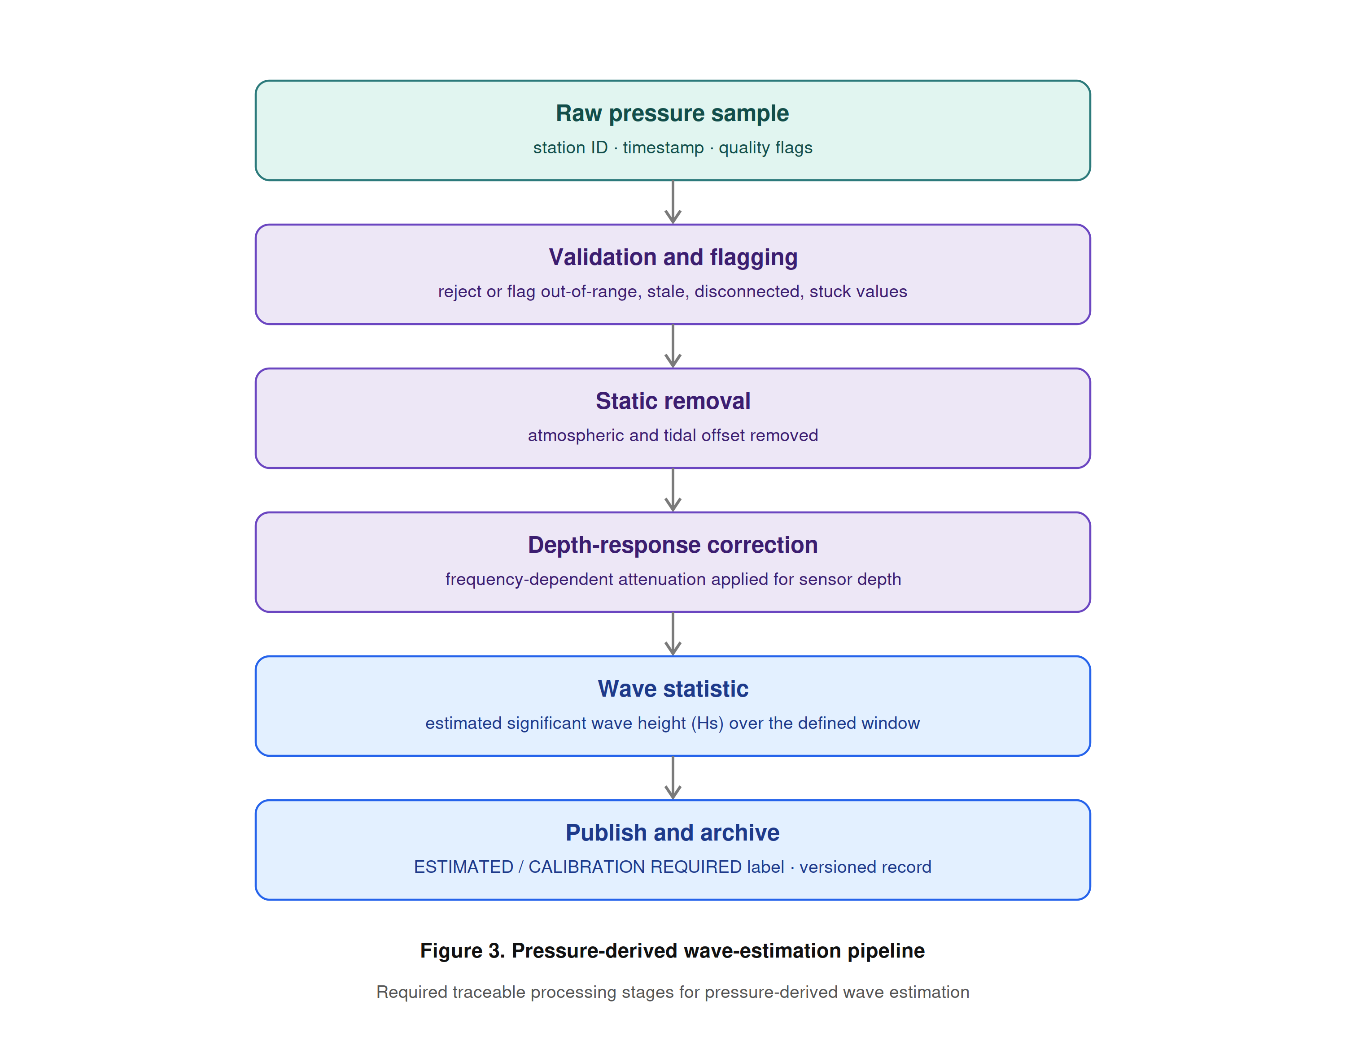
Figure 3. Pressure-derived wave-estimation pipeline
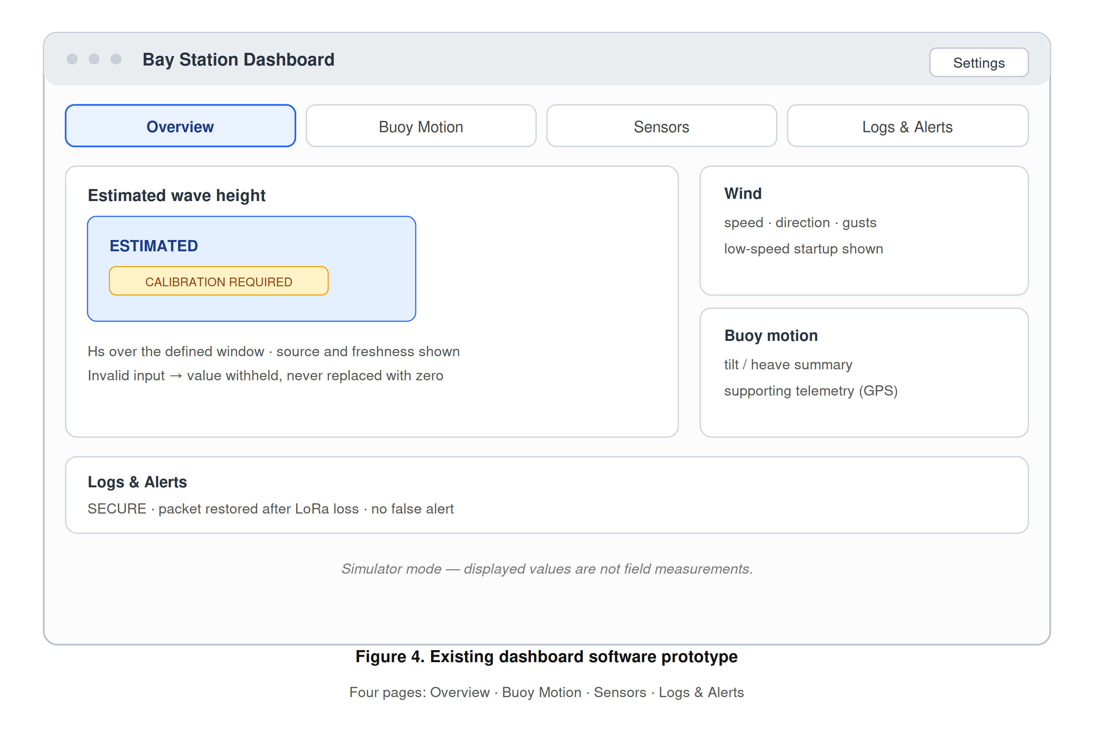
Figure 4. Existing dashboard software prototype
AI prediction procedure. One primary target is frozen — recommended as 10-minute-ahead estimated Hs — subject to adviser and stakeholder approval. Persistence and moving-average baselines are built before any linear, tree-based, GRU, or LSTM candidate is tested (Mo et al., 2024); data are split chronologically by deployment block or day, never by randomly mixing adjacent samples; and prediction is withheld whenever pressure input is invalid, stale, or uncalibrated, while monitoring continues if the AI component fails.
Energy, mechanical, and security procedures. A preliminary energy-budget worksheet (e.g., a 12.8 V, 6-10 Ah battery candidate at 80% usable capacity against a measured ESP32 plus modem duty-cycle load) is treated explicitly as a calculation, not a measurement, and is replaced by logged current data once hardware is frozen, consistent with energy-balance assessment for solar-powered IoT buoys (Wiranata & Widodo, 2026). The separate buoy and cloud/edge power boundaries are illustrated in Figure 5. The replacement compact can-buoy design must pass buoyancy, freeboard, center-of-gravity, stability/righting, top-housing and antenna load, mooring, corrosion, cable strain, ingress, condensation, sensor exposure, antenna clearance, retrieval, and serviceability review. Physical security uses SECURE, WARNING, ALERT, and DISARMED states, with geofence radius, GPS-quality limits, persistence time, maintenance controls, and tamper debounce documented.
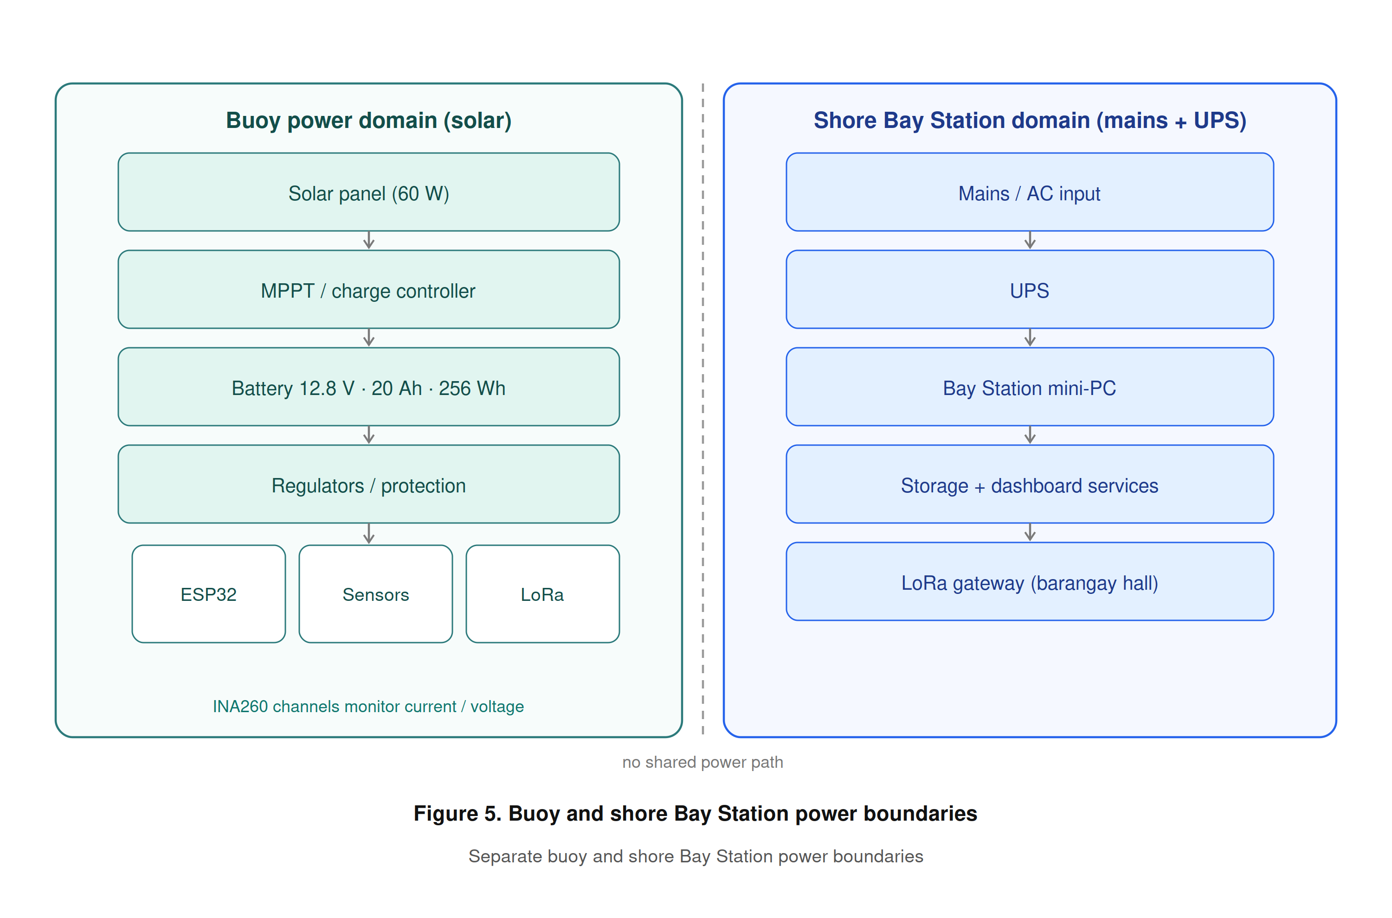
Figure 5. Buoy and cloud/edge service power boundaries

2.6 Testing and Evaluation
Evaluation is organized by area, each with primary metrics and an explicit release condition (Table 5). The evaluation is whole-system rather than component-by-component alone, in keeping with the central claim that honest integration and evidence is where the contribution lies (Figure 6).
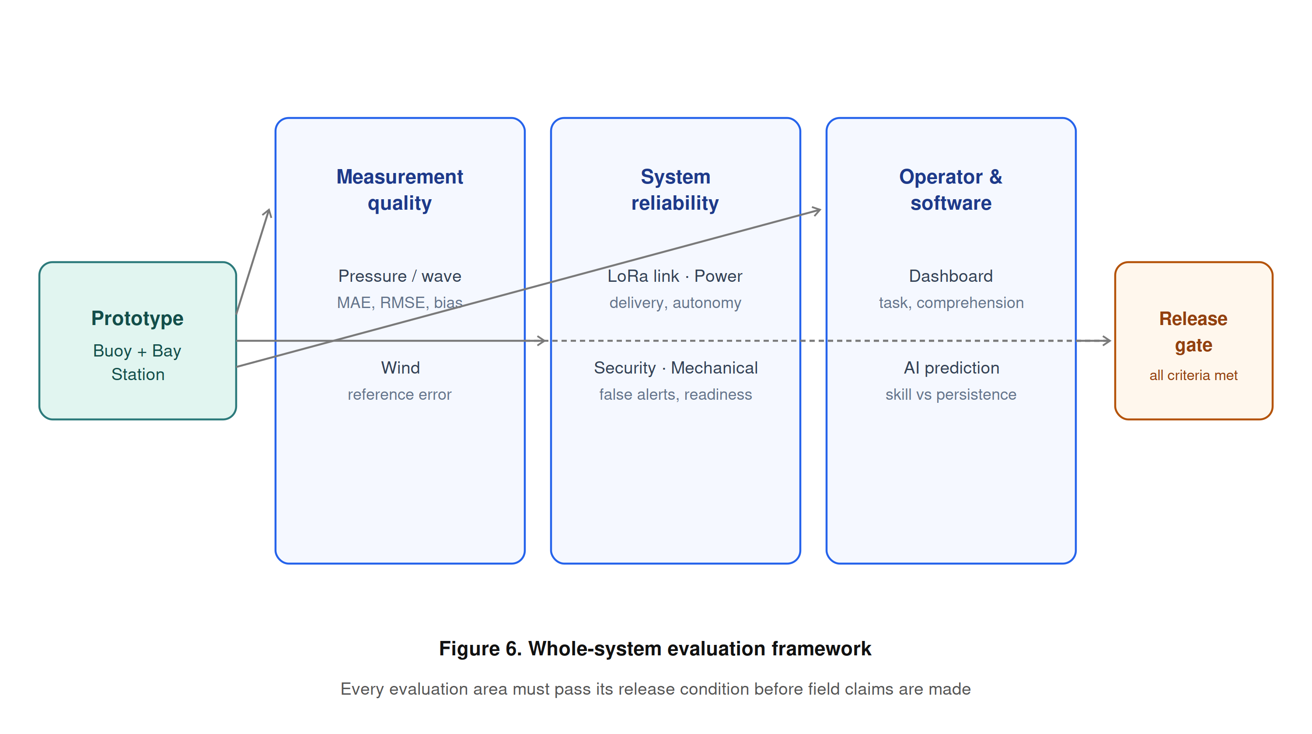
Figure 6. Whole-system evaluation framework
Table 5. Whole-System Evaluation Matrix
Area | Primary metrics / evidence | Release condition
Pressure / wave | MAE, RMSE, bias, repeatability, gaps, comparison plots | Median absolute wave-height error ≤ 0.10 m or ≤ 15% of reference, whichever is larger; period error ≤ 10% for regular tests; ≥ 95% valid windows.
Wind | Reference error, direction code, low-speed startup, repeatability | Mean error ≤ max(1.0 km/h, 10% of reference); all eight principal directions classified correctly.
Wi-Fi/LTE cloud upload | Packet delivery, latency, range, reconnect, duplicates, backlog recovery | ≥ 99% of test records received after planned outages; no duplicate records; reconnect in ≥ 29 of 30 cycles.
Power | Average/peak load, Wh/day, autonomy, reduced-sun recovery | Measured margin meets deployment target under measured load; autonomy and reduced-sun recovery verified.
Security | True/false alerts, detection delay, GPS scatter | No more than one false tamper alarm in a 24-hour supervised representative-motion test.
Dashboard | Task completion, errors, time, comprehension, readability | At least 5 representative users; ≥ 80% complete each task correctly on the first attempt.
AI | MAE/RMSE/bias, skill vs persistence, latency, availability | Held-out MAE improves on the persistence baseline by an adviser-approved margin.
Mechanical | Stability, ingress, corrosion control, retrieval inspection | No unsafe or unresolved critical failure
Statistical treatment. Sensor accuracy is reported using mean absolute error (MAE), root-mean-square error (RMSE), and bias against the independent reference, with repeatability (standard deviation) and percentage error. Communication is summarized by packet-delivery ratio, latency, reconnection time, duplicate count, and backlog-recovery time. Prediction performance reports MAE, RMSE, bias, skill relative to persistence, inference time, model size, missing-input behavior, and error by sea-condition range, with uncertainty based on observed residuals rather than an arbitrary confidence percentage (Bekiryazıcı et al., 2025; Chan et al., 2026).
Test scenarios. Controlled scenarios verify fault and recovery behavior (Table 6), ensuring that abnormal conditions surface as explicit, logged states rather than as silent failures or fabricated values.
Table 6. Controlled Test Scenarios
ID | Scenario | Expected observable behavior
P-01 | Pressure disconnected or implausible | Wave estimate and AI withheld; fault logged; no fabricated zero
C-01 | Wi-Fi/LTE cloud link interrupted | ESP32 buffers timestamped packets; retransmits without duplicate insertion
I-01 | cloud/edge service Internet interrupted | Local ingestion, storage, prediction, dashboard, alerts continue
G-01 | GPS scatter near geofence boundary | WARNING persistence prevents immediate false ALERT
T-01 | Enclosure opened while armed | Persistent event produces logged ALERT; maintenance DISARMED distinct
A-01 | AI model unavailable | Measured/estimated monitoring remains operational; prediction shows unavailable
B-01 | Low battery / reduced sunlight | Power warning, safe operating policy, and recovery are logged
R-01 | cloud/edge service restart | Services start automatically and stored records remain intact
Usability testing. Evaluators are given realistic tasks — identify the current wave estimate, verify GPS/security state, find a stale sensor, acknowledge an alert, and export records. The testing records task completion, completion time, navigation errors, assistance required, and label comprehension, and collects readability and confidence ratings using an adviser-approved usability instrument and sample. Because GNSS-based observations are useful only with appropriate processing and reference comparison (Knight et al., 2021), position data are interpreted with fix quality and persistence, and an isolated coordinate is never by itself treated as theft. The research instrument undergoes expert validation with a certificate of validation obtained before data gathering.

2.7 Ethical Considerations
Site, permits, and safety. Deployment requires written permission from the responsible site authority (e.g., the barangay or local government unit) and navigational and environmental review. Field work observes safe battery and electrical handling, defined weather limits, retrieval planning, and unambiguous prototype labeling so the public cannot mistake the buoy for an official installation.
Human participants. Usability participants — including older or non-technical operators — provide informed consent, and only the minimum necessary data are collected. Participants may withdraw at any time, and no personally identifying information is published without permission.
Public safety and honesty. The system must never issue or imply official warnings; operators are directed to PAGASA and competent authorities for all safety decisions (PAGASA, n.d.). The thesis maintains strict vocabulary discipline: pressure-derived output is presented only as estimated wave height, the AI output only as a research prediction, and simulator results are never described as physical measurements.
Data privacy and security. GPS locations are disclosed only to authorized users where a deployment partner regards them as sensitive. Cybersecurity controls include per-device identity, replay/duplicate protection, least-privilege operator access, TLS for Internet traffic, and audit records, protecting both the data and the individuals and communities associated with the deployment site. The study complies with the Philippine Data Privacy Act of 2012 (Republic Act No. 10173), collecting only the minimum necessary information, obtaining informed consent, and applying reasonable organizational and technical safeguards to personal data; any human-participant activity is subject to adviser and institutional ethics review.
Research integrity and environmental care. Intellectual honesty is enforced through version control of firmware, schemas, algorithms, and models; full retention of raw and processed data with quality metadata; and explicit documentation of limitations. Field activities minimize environmental disturbance, and all retrieved hardware and batteries are handled and disposed of responsibly.

EDITORIAL NOTES (remove before submission)
1. Methodological framework: confirm with the adviser that the cited framework (Creswell & Creswell, 2023; Richey & Klein, 2007) is the expected model.
2. These in-text citations still have no verified source and must be added or removed: Bekiryazıcı et al. (2025); Chan et al. (2026); Meulé et al. (2024); Mohammadi et al. (2024); Rojas et al. (2025); Suwardiyanto et al. (2024); Wiranata & Widodo (2026).
3. Embedded RRL text: outdated Orange Pi and BNO085 references were corrected to the current ESP32 + cloud/edge service baseline; review the embedded literature section once more.
4. Section 1.4 still needs its IPO figure; Chapter 2 figures were carried over from the source.

REFERENCES
Ardhuin, F., Stopa, J. E., Chapron, B., Collard, F., Husson, R., Jensen, R. E., Johannessen, J., Mouche, A., Passaro, M., Quartly, G. D., Swail, V., & Young, I. (2019). Observing sea states. Frontiers in Marine Science, 6, Article 124. https://doi.org/10.3389/fmars.2019.00124
Blue Robotics. (n.d.). Bar high-resolution depth/pressure sensors guide. https://bluerobotics.com/learn/bar-sensors-guide/
Cho, J., Kim, M. W., Kim, Y., Park, J.-S., Lee, D.-H., Kim, Y., & Kim, J. J. (2021). Seawater battery-based wireless marine buoy system with battery degradation prediction and multiple power optimization capabilities. IEEE Access, 9, 104104-104114. https://doi.org/10.1109/ACCESS.2021.3098846
Creswell, J. W., & Creswell, J. D. (2023). Research design: Qualitative, quantitative, and mixed methods approaches (6th ed.). SAGE.
Dreyer, L. W., Pferscher, A., Sieve, R., Rabault, J., Jensen, A., Johnsen, E. B., & Hope, G. (2026). OLB: An open Wi-Fi/LTE buoy for coastal water measurements [Preprint]. arXiv. https://doi.org/10.48550/arXiv.2601.05615
Fan, S., Xiao, N., & Dong, S. (2020). A novel model to predict significant wave height based on long short-term memory network. Ocean Engineering, 205, Article 107298. https://doi.org/10.1016/j.oceaneng.2020.107298
Grare, L., Statom, N. M., Pizzo, N., & Lenain, L. (2021). Instrumented Wave Gliders for air-sea interaction and upper ocean research. Frontiers in Marine Science, 8, Article 664728. https://doi.org/10.3389/fmars.2021.664728
Holykell. (n.d.). HPT604 Type A level sensor datasheet. https://www.holykell.com/wp-content/uploads/2023/08/HPT604A-Level-sensor-Datasheet-Holykell-V26-CS-1.pdf
Knight, P. J., Bird, C. O., Sinclair, A., Higham, J., & Plater, A. J. (2021). Beach deployment of a low-cost GNSS buoy for determining sea-level and wave characteristics. Geosciences, 11(12), Article 494. https://doi.org/10.3390/geosciences11120494
Liu, Y., Ning, C., Zhang, Q., Yuan, G., & Li, C. (2024). Research on ocean buoy attitude prediction model based on multi-dimensional feature fusion. Frontiers in Marine Science, 11, Article 1517170. https://doi.org/10.3389/fmars.2024.1517170
Martins, K., Blenkinsopp, C. E., & Zang, J. (2022). Measuring free surface elevation of shoaling waves with pressure transducers. Continental Shelf Research, 245, Article 104803. https://doi.org/10.1016/j.csr.2022.104803
Mo, J., Wang, X., Huang, S., & Wang, R. (2024). Advance in significant wave height prediction: A comprehensive survey. Complex System Modeling and Simulation, 4(4), 402-439. https://doi.org/10.23919/CSMS.2024.0019
National Mapping and Resource Information Authority. (2025). NAMRIA annual report 2025. https://www.namria.gov.ph/
Philippine Atmospheric, Geophysical and Astronomical Services Administration. (n.d.). Marine Meteorological Service Section: Functions and services. https://www.pagasa.dost.gov.ph/
Raja Ali, H. A. K., Alajuri, M. H. S., & Harahap, B. I. H. (2026). Implementation of IoT-based buoy position monitoring using GSM technology with SIM7000E module. Transactions on Maritime Science, 15(1). https://doi.org/10.7225/toms.v15.n01.002
Richey, R. C., & Klein, J. D. (2007). Design and development research. Routledge.
Skalvik, A. M., Saetre, C., Froysa, K.-E., Bjork, R. N., & Tengberg, A. (2023). Challenges, limitations, and measurement strategies to ensure data quality in deep-sea sensors. Frontiers in Marine Science, 10, Article 1152236. https://doi.org/10.3389/fmars.2023.1152236
Song, T., Wang, J., Huo, J., Wei, W., Han, R., Xu, D., & Meng, F. (2023). Prediction of significant wave height based on EEMD and deep learning. Frontiers in Marine Science, 10, Article 1089357. https://doi.org/10.3389/fmars.2023.1089357
Williams, Z., Soto Calvo, M. A., Lee, H. S., Aljber, M., & Jeong, J.-S. (2025). A low-cost autonomous multi-functional buoy for ocean currents and seawater parameter monitoring, and particle tracking. Journal of Marine Science and Engineering, 13(9), Article 1629. https://doi.org/10.3390/jmse13091629
Zhang, H., Zhang, D., & Zhang, A. (2020). An innovative multifunctional buoy design for monitoring continuous environmental dynamics at Tianjin Port. IEEE Access, 8, 171820-171833. https://doi.org/10.1109/ACCESS.2020.3024020
Zhou, F., Zhang, R., & Zhang, S. (2022). Measurement principle and technology of miniaturized strapdown inertial wave sensor. Frontiers in Marine Science, 9, Article 991996. https://doi.org/10.3389/fmars.2022.991996

